**1. Add a new row in the ORDERS table with the following data: Order# = 1021, Customer# = 1009, and Order date = July 20, 2009.**

INSERT INTO orders (order#, customer#, orderdate)

VALUES (1021, 1009, '20-JUL-2009')



**2. Modify the zip code on order 1017 to 33222.**

UPDATE orders

SET shipzip = 33222

WHERE ORDER# = 1017



**3. Save the changes permanently to the database.**

commit;

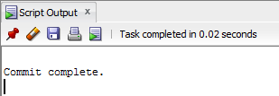

**4. Add a new row in the ORDERS table with the following data: Order# = 1022, Customer# = 2000, and Order date = August 6, 2009. Describe the error raised and what caused the error.**

INSERT INTO orders (order#, customer#, orderdate)

VALUES (1022, 2000, '06-AUG-2009')

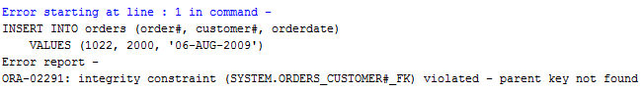

The error that was raised is in regards to a constraint violation; “parent key not found”.

**5. Add a new row in the ORDERS table with the following data: Order# = 1023 and**

**Customer# = 1009. Describe the error raised and what caused the error.**

INSERT INTO orders (order#, customer#)

VALUES (1023, 1009)

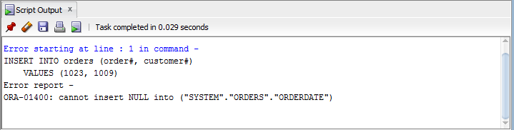

The error that was raised is in regards the orderdate column of the orders table not able to be null, since it was excluded in the new row that was to be added.

**6. Create a script using substitution variables that allows a user to set a new cost amount for a book based on the ISBN.**

UPDATE books

SET cost = '&cost'

WHERE ISBN = '&isbn';

**7. Execute the script and set the following values: isbn = 1059831198 and cost = $20.00.**

UPDATE books

SET cost = '&cost'

WHERE ISBN = '&isbn';

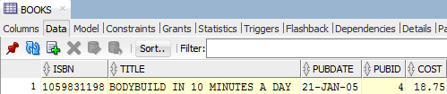

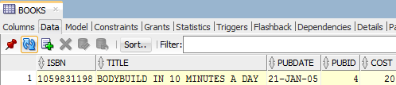

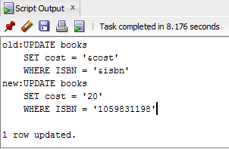

**8. Execute a command that undoes the change in Step 7.**

rollback

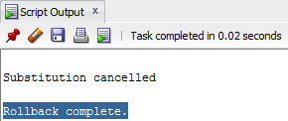



**9. Delete Order# 1005. You need to address both the master order record and the related detail records.**

DELETE FROM orderitems

WHERE order# = 1005

DELETE FROM orders

WHERE order# = 1005

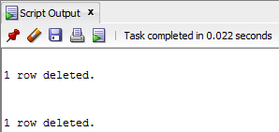

**10. Execute a command that undoes the previous deletion.**

rollback;

rollback;



